Name: B.Preethi

Trainer Name: Harshee Pitroda mam

Course Name: Python and Machine Learning-Basic course

Date:24/05/2022

Q1)

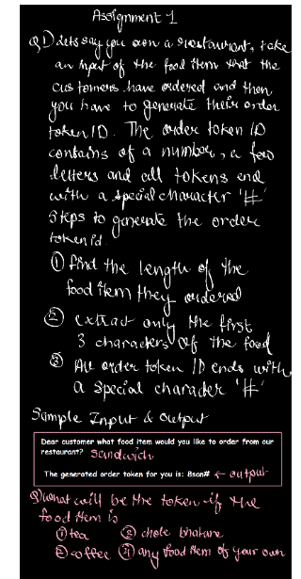

Code &Output:

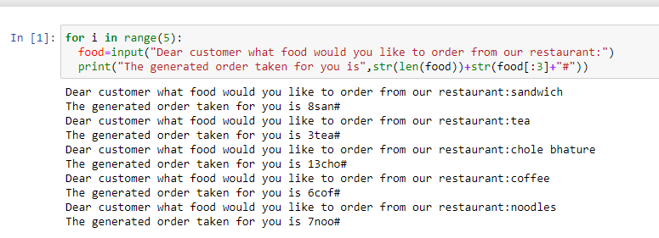

Q2)

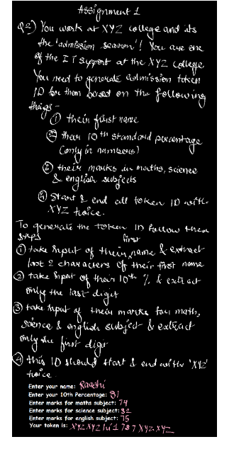

Code&Output:

